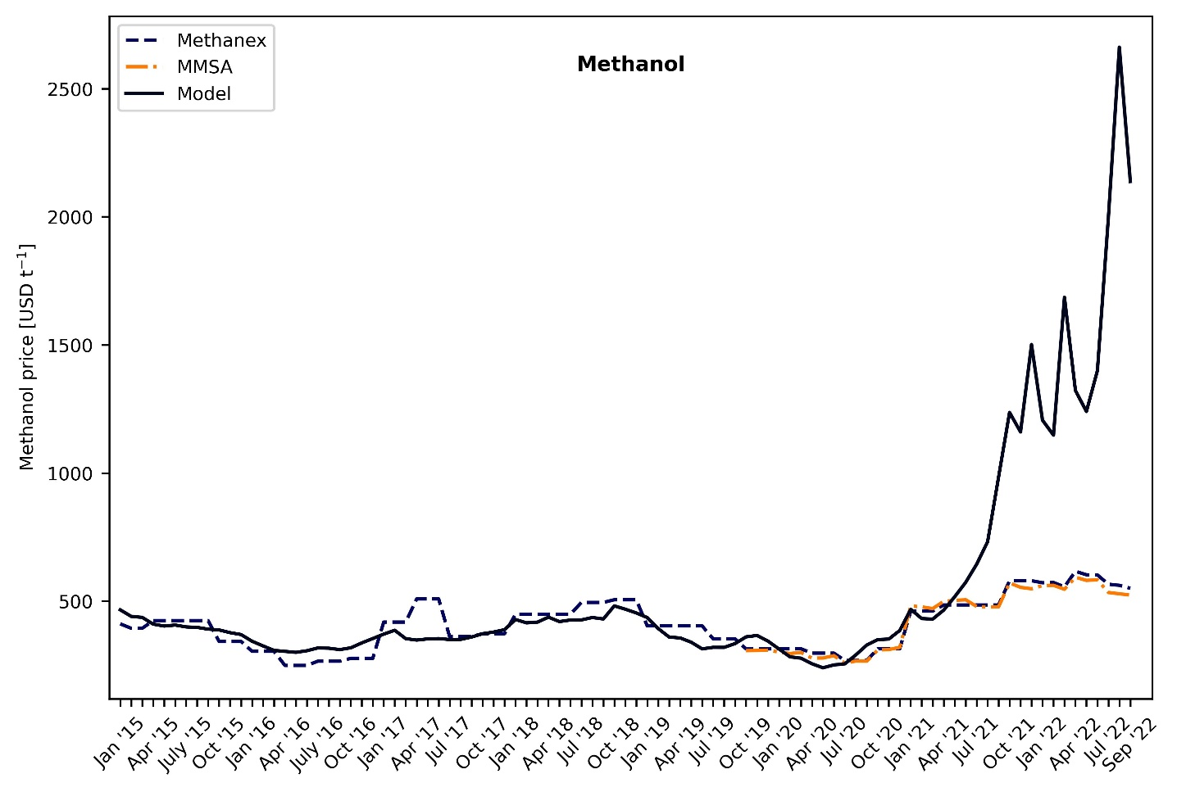
Figure 1 Methanol cost of production (model) vs. market price (literature).
Market prices for methanol in Europe are extracted from Methanex Corporation (January 2015 to September 2022) and Methanol Marketing Services Asia - MMSA (October 2019 to September 2022). MMSA is a consultancy service in Asia that does not provide sufficient information about the data sources. Methanex Corporation, on the other hand, is the world’s largest producer and supplier of methanol to major international markets. As shown in Figure 1, the data from both Methanex and MMSA are quite similar. Methanex has production sites in countries like Trinidad, New Zealand, Egypt, Canada, the United States, and Chile.
When comparing the cost of production calculated from our model and the market price of methanol, we see that from January 2015 to January 2021, the production costs harmonize well with the market prices of methanol. However, when the natural gas prices start becoming volatile, our model predicts production costs that are way higher than the market price of methanol in Europe. The reasons for this ambiguity are the following:
- Methanex and MMSA report the market prices of methanol. These prices are not the same as the cost of production in Europe. Rather, the methanol is imported and sold from the port of Rotterdam.
- Methanex has production sites in countries that are not affected by the current volatility of natural gas prices and hence produce methanol at a much lower price. When this methanol is exported to Europe, the market price is expected to be lower than the cost of production in Europe where the natural gas prices are the most impacted.
- Our model uses monthly average spot prices of natural gas TTF. One shortcoming of using these prices is that companies in theory will not buy natural gas at these prices. Rather, they depend on contracts. However, the price of natural gas agreed upon by different stakeholders will depend on the natural gas TTF index. Therefore, this analysis does not mean that companies are producing methanol at the prices shown in Figure 1, it rather shows that it is the right time to invest in alternative technologies so that Europe does not lose its industrial competitiveness.

